Lab 1:

**From Google Cloud Console**

1. Go to the IAM page in the GCP Console by visiting:

<https://console.cloud.google.com/iam-admin/iam>.

1. Click on Create service account

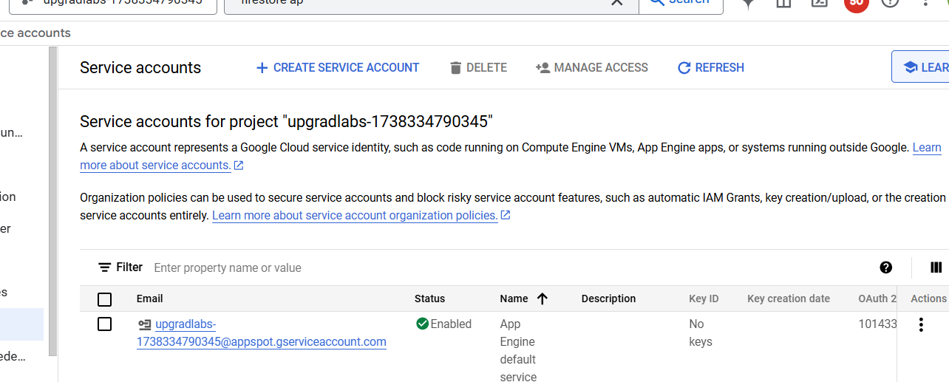

Provide details

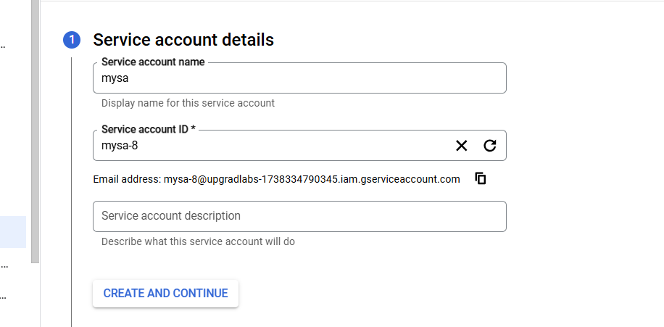

Provide access

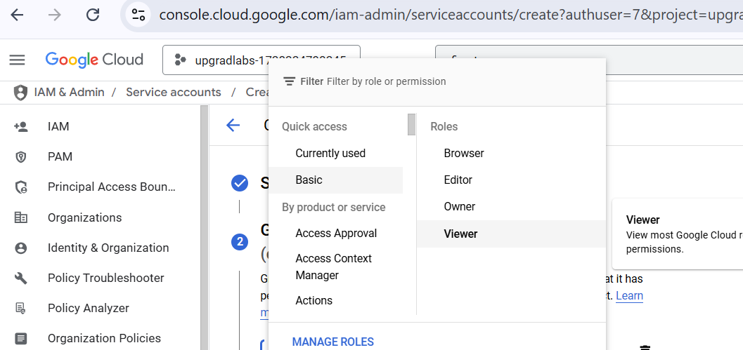

Click on continue

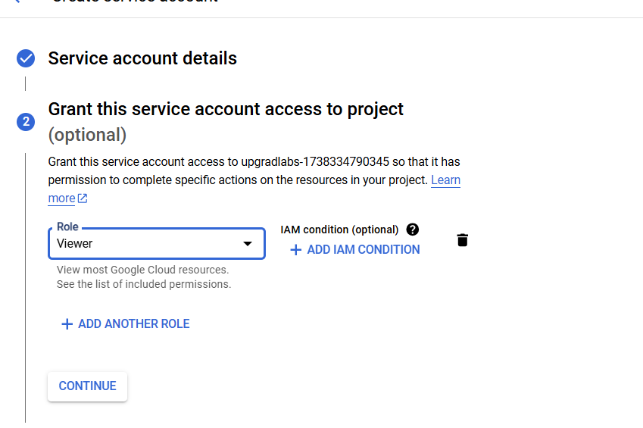

Click on done

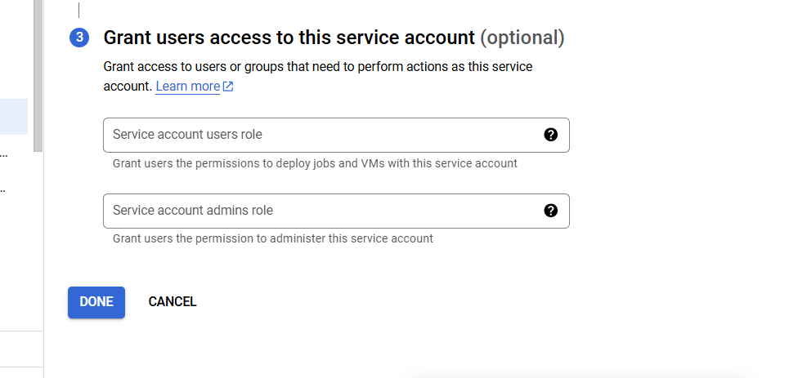

Lab 2:

**From Google Cloud Console**

1. Go to the IAM page in the GCP Console using

<https://console.cloud.google.com/iam-admin/iam>

2. In the left navigation pane, click Service accounts. All service accounts and their corresponding keys are listed.

3. Click the service account.

4. Click the edit and delete the keys.

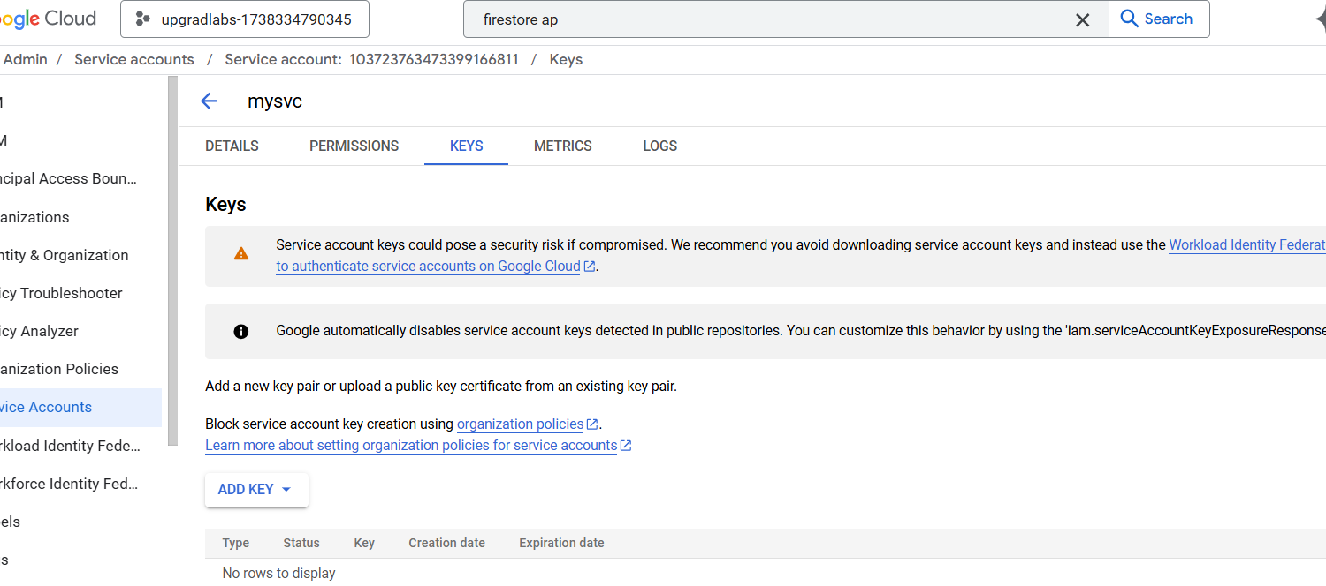

Lab 3:

**From Google Cloud Console**

1. Go to IAM & admin/IAM using <https://console.cloud.google.com/iam-admin/iam>

2. Under the IAM Tab look for VIEW BY PRINCIPALS

3. Filter PRINCIPALS using type : Service account

4. Look for the Service Account with the Principal nomenclature:

[**SERVICE_ACCOUNT_NAME@PROJECT_ID.iam.gserviceaccount.com**](mailto:SERVICE_ACCOUNT_NAME@PROJECT_ID.iam.gserviceaccount.com)

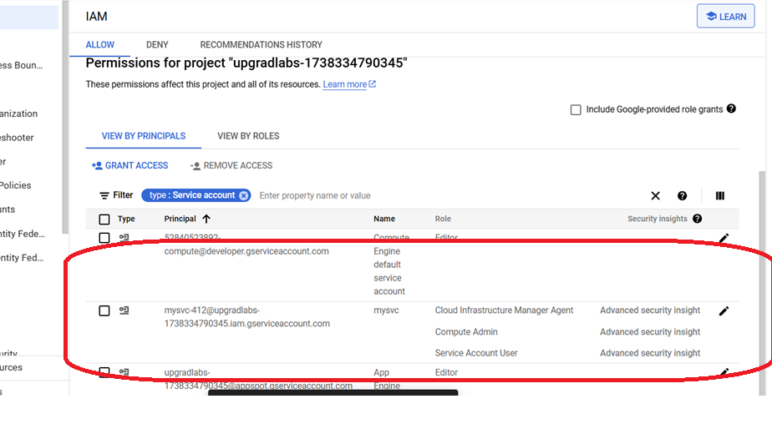

5. Identify User-Managed user created service account with roles containing *Admin or *admin or role matching Editor or role matching Owner under Role Column.

6. Click on Edit (Pencil Icon) for the Service Account, it will open all the roles which are assigned to the Service Account.

7. Click the Delete bin icon to remove the role from the Principal (service account